|  |
| --- |
| Session 1 outline: Understand this learning area  Australian Curriculum v9.0: The Arts — Prep–Year 6 |

This session outline provides an overview of the resources and key messages associated with the first recording in the Familiarisation and planning series for Australian Curriculum v9.0: The Arts — Prep–Year 6, Understand this learning area.

## Resources and links used

* [The Arts v9.0: Understand this learning area](https://v9.australiancurriculum.edu.au/teacher-resources/understand-this-learning-area/the-arts) (Australian Curriculum)
* [The Alice Springs (Mparntwe) Education Declaration](https://www.education.gov.au/alice-springs-mparntwe-education-declaration/resources/alice-springs-mparntwe-education-declaration)
* [General capabilities advice and resources](https://www.qcaa.qld.edu.au/p-10/aciq/version-9/general-capabilities/advice-and-resources) (QCAA)
* [Cross-curriculum priorities advice and resources](https://www.qcaa.qld.edu.au/p-10/aciq/version-9/cross-curriculum-priorities) (QCAA)

## Activities

|  |  |
| --- | --- |
| Learning goal | Success criteria |
| Understand implications of changes to the Australian Curriculum v9.0: The Arts — Prep–Year 6 to plan for the transition in your own context. | You will know you are successful if you:   * have more knowledge about the intent and structure of the learning area in Australian Curriculum v9.0: The Arts * can identify actions for planning in your school. |

### Identifying actions for planning in your context

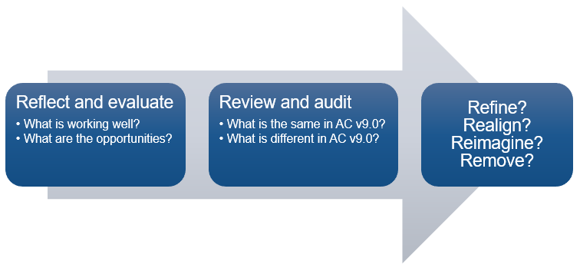

### Pause and reflect: Similarities and differences

|  |  |
| --- | --- |
| What is the same in AC v9.0? | What is different in AC v9.0? |
|  |  |

### Pause and reflect: Rationale and aims

1. Go to: [The Arts v9.0: Understand this learning area](https://v9.australiancurriculum.edu.au/teacher-resources/understand-this-learning-area/the-arts) (Australian Curriculum)
2. Review the rationale and the aims, identifying the big ideas and/or main points.
3. Reflect on your school’s The Arts program and the intent of the Education Declaration.

|  |
| --- |
| What do you want to see in your school’s The Arts program moving forward? |
|  |

### Pause and reflect: Key messages

To what extent did each key message resonate with you? Circle your response.

1 = Did not resonate; 5 = Resonated very strongly.

**A world-class curriculum is the vision for education in Australia.**

|  |  |  |  |  |
| --- | --- | --- | --- | --- |
| 1 | 2 | 3 | 4 | 5 |

**The rationale and aims provide the purpose for teaching The Arts.**

|  |  |  |  |  |
| --- | --- | --- | --- | --- |
| 1 | 2 | 3 | 4 | 5 |

**The four strands are integrated in planning.**

|  |  |  |  |  |
| --- | --- | --- | --- | --- |
| 1 | 2 | 3 | 4 | 5 |

**The key considerations inform the teaching of The Arts.**

|  |  |  |  |  |
| --- | --- | --- | --- | --- |
| 1 | 2 | 3 | 4 | 5 |

**The Examples of knowledge and skills can provide support for understanding subject-specific content.**

|  |  |  |  |  |
| --- | --- | --- | --- | --- |
| 1 | 2 | 3 | 4 | 5 |

### Pause and reflect: Identifying actions

1. Evaluate the similarities and differences you have noted from the Understand this learning area section.
2. Identify 2–3 actions you will now take to plan for The Arts v9.0 in your context.

|  |  |  |
| --- | --- | --- |
| Action | Resources required | Additional notes |
|  |  |  |
|  |  |  |
|  |  |  |

## Familiarisation and planning resources

QCAA’s v9.0: The Arts resources can be found using the following links:

* [Summary of changes in Australian Curriculum Version 9.0: The Arts](https://www.qcaa.qld.edu.au/downloads/aciqv9/the-arts/curriculum/ac9_arts_summary_changes.pdf)
* [Comparison of AC 8.4 to v9.0 P–6 The Arts](https://www.qcaa.qld.edu.au/p-10/aciq/version-9/learning-areas/p-10-the-arts)
  + Select your Arts subject
  + Select ‘Understanding v9.0’
  + Explore P–6 comparison resources.
* [Sequence of achievement standards P–6 The Arts](https://www.qcaa.qld.edu.au/p-10/aciq/version-9/learning-areas/p-10-the-arts)
  + Select your Arts subject
  + Select ‘Achievement standards and content descriptions v9.0’
  + Explore P–6 sequence of achievement standards resources.
* [Curriculum and assessment plan templates and samples P–6 The Arts](https://www.qcaa.qld.edu.au/p-10/aciq/version-9/learning-areas/p-10-the-arts)
  + Select your Arts subject
  + Select ‘Planning’ tab
  + Select ‘Curriculum and assessment plans’
  + Explore ‘Templates’
  + Explore ‘Multi-age templates’
  + Explore ‘Samples’.
* [Standards elaborations](https://www.qcaa.qld.edu.au/p-10/aciq/version-9/learning-areas/p-10-the-arts)
  + Select your Arts subject
  + Select ‘Assessment’ tab
  + Select ‘Standards elaborations’
  + Explore P–6 standards elaborations.

## More information

If you would like more information, please visit the QCAA website [www.qcaa.qld.edu.au](http://www.qcaa.qld.edu.au/). Alternatively, email the K–10 Curriculum and Assessment branch at [australiancurriculum@qcaa.qld.edu.au](mailto:australiancurriculum@qcaa.qld.edu.au).

[](https://www.qcaa.qld.edu.au/copyright) © State of Queensland (QCAA) 2024

**Licence:** <https://creativecommons.org/licenses/by/4.0> **| Copyright notice:** [www.qcaa.qld.edu.au/copyright](https://www.qcaa.qld.edu.au/copyright) —   
lists the full terms and conditions, which specify certain exceptions to the licence. **|   
Attribution** (include the link): © State of Queensland ([QCAA](https://www.qcaa.qld.edu.au/copyright)) 2024 [www.qcaa.qld.edu.au/copyright](https://www.qcaa.qld.edu.au/copyright).