|  |
| --- |
| Session 3 outline: Understand this learning area  Prep–Year 6 Australian Curriculum v9.0 |

This session outline provides an overview of the resources and key messages associated with the third recording in the Familiarisation and planning series.

## Resources and links used

* Select a learning area to view **Understand this learning area** and the **Curriculum elements**: [P-10 Australian Curriculum v9.0 landing page](https://v9.australiancurriculum.edu.au/) (ACARA)
* Select a learning area to view the QCAA resources:  
  [Australian Curriculum Version 9.0 in Queensland](https://www.qcaa.qld.edu.au/p-10/aciq/version-9/learning-areas) (QCAA)
* [Planning for teaching, learning and assessment: Prep–Year 10](https://www.qcaa.qld.edu.au/downloads/aciq/general-resources/teaching/ac_plan_teach_learn_assess.pdf) (QCAA)

## Activities

|  |  |
| --- | --- |
| Learning goal | Success criteria |
| Understand implications of changes to the Prep–Year 6 Australian Curriculum Version 9.0 to plan for the transition in your own context. | You will know you are successful if you:   * can apply your knowledge about the Australian Curriculum Version 9.0 to whole-school, year level and unit planning * can identify actions for planning in your school. |

### Identifying actions for planning in your context

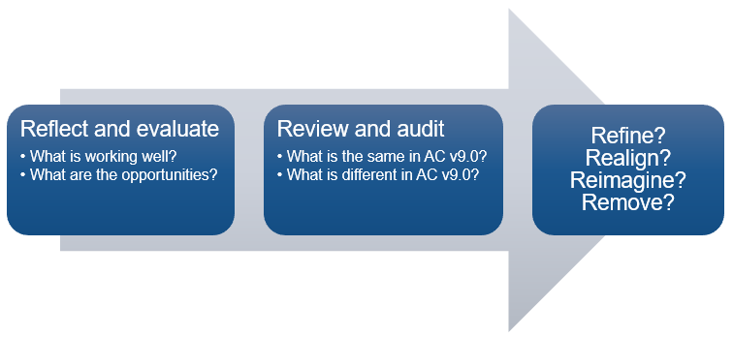

### Pause and reflect: Whole school curriculum and assessment planning

1. Consider your school context and its priorities.

|  |
| --- |
| Record two ways your school context influences how you plan teaching and learning programs for students in the primary years. |
|  |

### Pause and reflect: Planning for primary years learners

1. Consider how you plan for primary years learners.

|  |  |
| --- | --- |
| Which qualities of primary learners have been reflected in your plans? | Where are there opportunities to enhance your plans to reflect the qualities of primary learners? |
|  |  |

### Pause and reflect: Achievement standards aligned to content descriptions

1. Download the QCAA resource, achievement standard aligned to content descriptions, for a learning area and year level/band you would like to work with (a link to the QCAA Learning area pages is provided in the **Resources and links used** section above).
2. Review the alignment between content descriptions and achievement standard statements.

|  |
| --- |
| What are the implications for teaching, learning and assessment in your context? |
|  |

### Pause and reflect: Planning in your context

Reflect on your own school planning in Prep–Year 6.

|  |  |
| --- | --- |
| What are we doing now? | What opportunities are provided by the implementation of a new version of the curriculum? |
|  |  |

#### Pause and reflect: Examples of possible actions

Select which actions might be useful for you in your school context.

Conduct SWOT analysis of current units

Identify and plan professional development needed for teachers

Investigate budget requirements for new resources, e.g. additional texts

Develop a plan to create year plans, units and assessment tasks

Nominate staff to take responsibility for each year level or a unit — year level ‘champion’

Form a cluster of like-schools to share learning and resources

#### Pause and reflect: QCAA resources

Select those resources you have not accessed yet and/or would like to use in your planning for v9.0:

Comparison of AC v8.4 to v9.0 (P–10)

Sequence of achievement standards

Sequence of content descriptions

Achievement standard aligned to content descriptions (P–10)

Prepopulated curriculum and assessment plans (P–10)

Curriculum and assessment plan samples

Assessment techniques and conditions (P–10)

Standards elaborations

Standards elaborations: glossary of qualifiers

## More information

If you would like more information, please visit the QCAA website [www.qcaa.qld.edu.au](http://www.qcaa.qld.edu.au/). Alternatively, email the K–10 Curriculum and Assessment branch at [australiancurriculum@qcaa.qld.edu.au](mailto:australiancurriculum@qcaa.qld.edu.au).

[](https://www.qcaa.qld.edu.au/copyright) © State of Queensland (QCAA) 2024

**Licence:** <https://creativecommons.org/licenses/by/4.0> **| Copyright notice:** [www.qcaa.qld.edu.au/copyright](https://www.qcaa.qld.edu.au/copyright) —   
lists the full terms and conditions, which specify certain exceptions to the licence. **|   
Attribution** (include the link): © State of Queensland ([QCAA](https://www.qcaa.qld.edu.au/copyright)) 2024 [www.qcaa.qld.edu.au/copyright](https://www.qcaa.qld.edu.au/copyright).