|  |
| --- |
| Session 1 outline: Understand this learning area  Australian Curriculum v9.0: HASS Prep–Year 6 |

This session outline provides an overview of the resources and key messages associated with the first recording in the Familiarisation and planning series for Australian Curriculum v9.0: HASS P–6, Understand this learning area.

## Resources and links used

* [Humanities and Social Sciences v9.0: Understand this learning area](https://v9.australiancurriculum.edu.au/teacher-resources/understand-this-learning-area/humanities-and-social-sciences) (Australian Curriculum)
* [HASS P–6 v9.0: Understand this learning area](https://v9.australiancurriculum.edu.au/teacher-resources/understand-this-learning-area/humanities-and-social-sciences#hass-f-6) (Australian Curriculum)
* [The Alice Springs (Mparntwe) Education Declaration](https://www.education.gov.au/alice-springs-mparntwe-education-declaration/resources/alice-springs-mparntwe-education-declaration)
* [General capabilities advice and resources](https://www.qcaa.qld.edu.au/p-10/aciq/version-9/general-capabilities/advice-and-resources) (QCAA)
* [Cross-curriculum priorities advice and resources](https://www.qcaa.qld.edu.au/p-10/aciq/version-9/cross-curriculum-priorities) (QCAA)

## Activities

|  |  |
| --- | --- |
| Learning goal | Success criteria |
| Understand implications of changes to the Australian Curriculum v9.0: HASS P–6 to plan for the transition in your own context. | You will know you are successful if you:   * have more knowledge about the intent and structure of Australian Curriculum v9.0: HASS P–6 * can identify actions for planning in your school. |

### Identifying actions for planning in your context

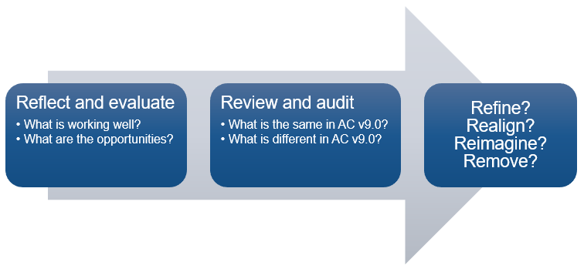

### Pause and reflect: Similarities and differences

|  |  |
| --- | --- |
| What is the same in AC v9.0? | What is different in AC v9.0? |
|  |  |

### Pause and reflect: Rationale and aims

1. Go to: [Humanities and Social Sciences v9.0: Understand this learning area](https://v9.australiancurriculum.edu.au/teacher-resources/understand-this-learning-area/humanities-and-social-sciences#hass-f-6) — HASS P–6 (Australian Curriculum).
2. Review the rationale and the aims, identifying the big ideas and/or main points.
3. Reflect on your school’s HASS P–6 program and the intent of the Education Declaration.

|  |
| --- |
| What do you want to see in your school’s P–6 HASS program moving forward? |
|  |

### Pause and reflect: Key messages

To what extent did each key message resonate with you? Circle your response.

1 = Did not resonate; 5 = Resonated very strongly.

**A world-class curriculum is the vision for education in Australia.**

|  |  |  |  |  |
| --- | --- | --- | --- | --- |
| 1 | 2 | 3 | 4 | 5 |

**The rationale and aims provide the purpose for teaching P–6** **HASS.**

|  |  |  |  |  |
| --- | --- | --- | --- | --- |
| 1 | 2 | 3 | 4 | 5 |

**The two strands remain and are integrated in planning.**

|  |  |  |  |  |
| --- | --- | --- | --- | --- |
| 1 | 2 | 3 | 4 | 5 |

**The key considerations inform the teaching of P–6** **HASS.**

|  |  |  |  |  |
| --- | --- | --- | --- | --- |
| 1 | 2 | 3 | 4 | 5 |

**The glossary can clarify the curriculum.**

|  |  |  |  |  |
| --- | --- | --- | --- | --- |
| 1 | 2 | 3 | 4 | 5 |

### Pause and reflect: Identifying actions

1. Evaluate the similarities and differences you have noted from the Understanding this learning area section.
2. Identify 2–3 actions you will now take to plan for HASS P–6 v9.0 in your context.

|  |  |  |
| --- | --- | --- |
| Action | Resources required | Additional notes |
|  |  |  |
|  |  |  |
|  |  |  |

## Familiarisation and planning resources

QCAA’s v9.0: HASS P–6 resources can be found using the following links:

* [Summary of changes in Australian Curriculum Version 9.0: HASS P–6](https://www.qcaa.qld.edu.au/downloads/aciqv9/humanities-and-social-sciences/curriculum/ac9_hass_summary_changes.pdf)
* [Comparison of AC v8.4 to v9.0 HASS P–6](https://www.qcaa.qld.edu.au/p-10/aciq/version-9/learning-areas/p-10-humanities-and-social-sciences/hass)
  + Select ‘Understanding v9.0’
  + Explore HASS P–6 comparison resources.
* [Sequence of achievement standards HASS P–6](https://www.qcaa.qld.edu.au/downloads/aciqv9/humanities-and-social-sciences/curriculum/ac9_hass_prep-yr6_as_sequence.pdf)
* [Curriculum and assessment plan templates and samples HASS P–6](https://www.qcaa.qld.edu.au/p-10/aciq/version-9/learning-areas/p-10-humanities-and-social-sciences/hass/planning)
  + Select ‘Curriculum and assessment plans’
  + Explore ‘Templates’ HASS P–6 curriculum and assessment plans
  + Explore ‘Samples’ HASS P–6 curriculum and assessment plans.
* [Multi-age curriculum and assessment template P–6](https://www.qcaa.qld.edu.au/p-10/aciq/version-9/learning-areas/p-10-humanities-and-social-sciences/hass/planning)
* [Standards elaborations](https://www.qcaa.qld.edu.au/p-10/aciq/version-9/learning-areas/p-10-humanities-and-social-sciences/hass/assessment)
  + Select ‘Standards elaborations’
  + Explore HASS P–6 standard elaborations.

## More information

If you would like more information, please visit the QCAA website [www.qcaa.qld.edu.au](http://www.qcaa.qld.edu.au/). Alternatively, email the K–10 Curriculum and Assessment branch at [australiancurriculum@qcaa.qld.edu.au](mailto:australiancurriculum@qcaa.qld.edu.au).

[](https://www.qcaa.qld.edu.au/copyright) © State of Queensland (QCAA) 2024

**Licence:** <https://creativecommons.org/licenses/by/4.0> **| Copyright notice:** [www.qcaa.qld.edu.au/copyright](https://www.qcaa.qld.edu.au/copyright) —   
lists the full terms and conditions, which specify certain exceptions to the licence. **|   
Attribution** (include the link): © State of Queensland ([QCAA](https://www.qcaa.qld.edu.au/copyright)) 2024 [www.qcaa.qld.edu.au/copyright](https://www.qcaa.qld.edu.au/copyright).