Quality assurance

Curriculum and assessment plans

A curriculum and assessment plan (CAP) provides an overview of the teaching, learning and assessment within a learning area/subject for each year level/band (or multiple year levels/bands in multi-age contexts).
This quality assurance document has been compiled to support teachers and school leaders to refine and strengthen the quality of a CAP before implementing it with students.
Learning area/subject
Year level
Implementation year
If the CAP satisfies the areas identified below, mark the box in the ‘Yes’ column. If ‘No’, write a comment offering advice on how to improve.
Checking for quality |  | Yes | No | Improvements
The curriculum and assessment plan:
 | - considers the context and cohort, including  - relevant student data and information  - available resources  - school and sector priorities | ☐ | ☐
 | - identifies learning and assessment contexts that are relevant, engaging and provide a reasonable challenge to students | ☐ | ☐
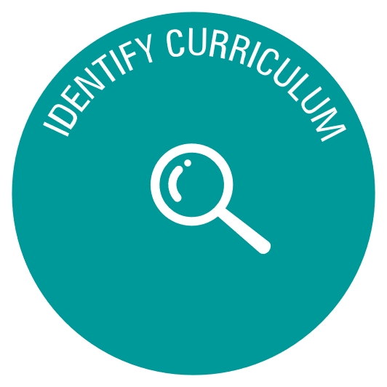 | - reflects the intent of the  - rationale and aims  - key considerations | ☐ | ☐
 | - considers the level description | ☐ | ☐
 | - identifies the aspects of the achievement standard to be assessed in each unit | ☐ | ☐
 | - identifies the content descriptions to be taught in each unit | ☐ | ☐
 | - considers alignment between the identified aspects of the achievement standard and content descriptions in each unit | ☐ | ☐
 | - ensures coverage of the achievement standard and content descriptions | ☐ | ☐
 | - embeds relevant general capabilities | ☐ | ☐
 | - embeds cross-curriculum priorities, where appropriate | ☐ | ☐
 | - identifies links to other learning areas/subjects, where appropriate | ☐ | ☐
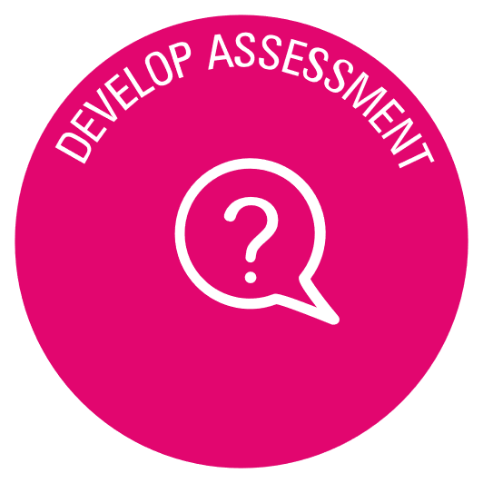 | - aligns assessment tasks to the unit descriptions | ☐ | ☐
 | - identifies for each assessment task  - assessment title and description  - technique, modes and conditions  - timing of the assessment | ☐ | ☐
 | - considers reporting processes and timelines | ☐ | ☐
 | - provides a range and balance of appropriate assessment techniques, modes and conditions | ☐ | ☐
 | - provides opportunities for students to demonstrate the depth and breadth of their learning | ☐ | ☐
 | - considers the scope and sequence of units across the year level/band, including  - progression of content and skills  - meaningful grouping of content within and/or across strands/sub-strands  - opportunities for practice | ☐ | ☐
 | - considers prior and future learning across the year level/band | ☐ | ☐
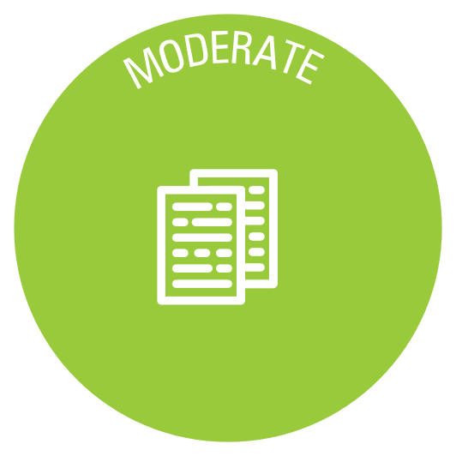 | - identifies moderation details, including  - when moderation will occur  - how it will be conducted. | ☐ | ☐
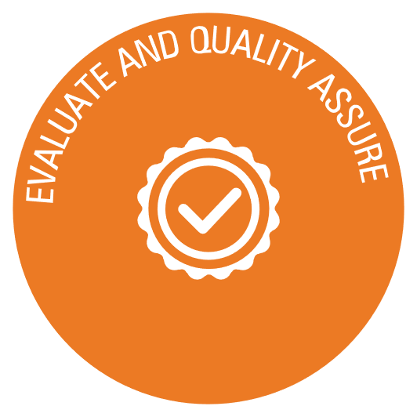 | Action required
Teacher/s |  | Date
School leader/s
Template Quality assurance: Curriculum and assessment plans originally published by QCAA 2024. CC BY 4.0. No attribution is required.

