|  |
| --- |
| Session 1 outline: Understand this learning area  Australian Curriculum v9.0: English — Prep–Year 6 |

This session outline provides an overview of the resources and key messages associated with the first recording in the Familiarisation and planning series for Australian Curriculum v9.0: English — Prep–Year 6, Understand this learning area.

## Resources and links used

* [English v9.0: Understand this learning area](https://v9.australiancurriculum.edu.au/teacher-resources/understand-this-learning-area/english) (ACARA)
* [The Alice Springs (Mparntwe) Education Declaration](https://www.education.gov.au/alice-springs-mparntwe-education-declaration/resources/alice-springs-mparntwe-education-declaration)
* [General capabilities advice and resources](https://www.qcaa.qld.edu.au/p-10/aciq/version-9/general-capabilities/advice-and-resources) (QCAA)
* [Cross-curriculum priorities advice and resources](https://www.qcaa.qld.edu.au/p-10/aciq/version-9/cross-curriculum-priorities) (QCAA)

## Activities

|  |  |
| --- | --- |
| **Learning goal** | **Success criteria** |
| Understand implications of changes to the Australian Curriculum v9.0: English — Prep–Year 6 to plan for the transition in your own context. | You will know you are successful if you:   * have more knowledge about the intent and structure of the learning area in Australian Curriculum v9.0: English * can identify actions for planning in your school. |

### Identifying actions for planning in your context

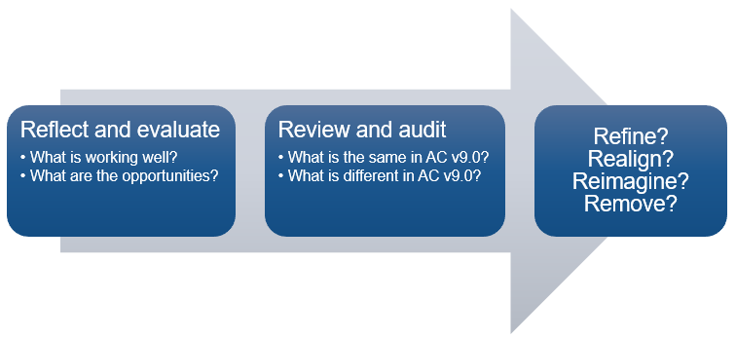

### Pause and reflect: Similarities and differences

|  |  |
| --- | --- |
| What is the same in AC v9.0? | What is different in AC v9.0? |
|  |  |

### Pause and reflect: Rationale and aims

1. Go to: [English v9.0: Understand this learning area](https://v9.australiancurriculum.edu.au/teacher-resources/understand-this-learning-area/english) (ACARA)
2. Review the rationale and the aims, identifying the big ideas and/or main points.
3. Reflect on your school’s English program and the intent of the Education Declaration.

|  |
| --- |
| What do you want to see in your school’s English program moving forward? |
|  |

### Pause and reflect: Key messages

To what extent did each key message resonate with you? Circle your response.

1 = Did not resonate; 5 = Resonated very strongly.

**A world-class curriculum is the vision for education in Australia.**

|  |  |  |  |  |
| --- | --- | --- | --- | --- |
| 1 | 2 | 3 | 4 | 5 |

**The rationale and aims provide the purpose for teaching English.**

|  |  |  |  |  |
| --- | --- | --- | --- | --- |
| 1 | 2 | 3 | 4 | 5 |

**The three strands remain and are integrated in planning.**

|  |  |  |  |  |
| --- | --- | --- | --- | --- |
| 1 | 2 | 3 | 4 | 5 |

**The key considerations inform the teaching of English.**

|  |  |  |  |  |
| --- | --- | --- | --- | --- |
| 1 | 2 | 3 | 4 | 5 |

**The glossary can clarify the curriculum.**

|  |  |  |  |  |
| --- | --- | --- | --- | --- |
| 1 | 2 | 3 | 4 | 5 |

### Pause and reflect: Identifying actions

1. Evaluate the similarities and differences you have noted from the Understand this learning area section.
2. Identify 2–3 actions you will now take to plan for English v9.0 in your context.

|  |  |  |
| --- | --- | --- |
| Action | Resources required | Additional notes |
|  |  |  |
|  |  |  |
|  |  |  |

## Familiarisation and planning resources

QCAA’s v9.0: English resources can be found using the following links:

* [Summary of changes in Australian Curriculum Version 9.0: English](https://www.qcaa.qld.edu.au/downloads/aciqv9/english/curriculum/ac9_english_summary_changes.pdf)
* [Comparison of AC 8.4 to v9.0 P-6 English](https://www.qcaa.qld.edu.au/p-10/aciq/version-9/learning-areas/p-10-english/p-10-english-planning)
  + Select ‘Understanding v9.0’
  + Explore P-6 English comparison resources.
* [Sequence of achievement standards P-6 English](https://www.qcaa.qld.edu.au/downloads/aciqv9/english/curriculum/ac9_english_prep-yr6_as_sequence.pdf)
* [Curriculum and assessment plan templates and samples P-6 English](https://www.qcaa.qld.edu.au/p-10/aciq/version-9/learning-areas/p-10-english/p-10-english-planning)
  + Select ‘Curriculum and assessment plans’
  + Explore ‘Templates’ P-6 English curriculum and assessment plans
  + Explore ‘Samples’ P-6 English curriculum and assessment plans.
* [Multi-age curriculum and assessment template P-6](https://www.qcaa.qld.edu.au/downloads/aciqv9/english/planning/ac9_english_p-6_cap_multi.docx)
* [Standards elaborations](https://www.qcaa.qld.edu.au/p-10/aciq/version-9/learning-areas/p-10-english/p-10-english-assessment)
  + Select ‘Standards elaborations’
  + Explore P-6 English standard elaborations.

## More information

If you would like more information, please visit the QCAA website [www.qcaa.qld.edu.au](http://www.qcaa.qld.edu.au/). Alternatively, email the K–10 Curriculum and Assessment branch at [australiancurriculum@qcaa.qld.edu.au](mailto:australiancurriculum@qcaa.qld.edu.au).

[](https://www.qcaa.qld.edu.au/copyright) © State of Queensland (QCAA) 2024

**Licence:** <https://creativecommons.org/licenses/by/4.0> **| Copyright notice:** [www.qcaa.qld.edu.au/copyright](https://www.qcaa.qld.edu.au/copyright) —   
lists the full terms and conditions, which specify certain exceptions to the licence. **|   
Attribution** (include the link): © State of Queensland ([QCAA](https://www.qcaa.qld.edu.au/copyright)) 2024 [www.qcaa.qld.edu.au/copyright](https://www.qcaa.qld.edu.au/copyright).